**DAILY ONLINE ACTIVITIES SUMMARY**

|  |  |  |  |  |  |  |  |
| --- | --- | --- | --- | --- | --- | --- | --- |
| **Date:** | **26st MAY 2020** | | | | **Name:** | **K.ISHA HEGDE.** | |
| **Sem & Sec** | **4sem A** | | | | **USN:** | **4al18cs031** | |
| **Online Test Summary** | | | | | | | |
| **Subject** | | **DAA** | | | | | |
| **Max. Marks** | | **30** | | **Score** | | **26** | |
| **Certification Course Summary** | | | | | | | |
| **Course** | **Digital security awareness** | | | | | | |
| **Certificate Provider** | | | **ALISON** | **Duration** | | | **1.5 hrs** |
| **Coding Challenges** | | | | | | | |
| **Problem Statement:2 programs** | | | | | | | |
| **Status:executed** | | | | | | | |
| **Uploaded the report in Github** | | | | **Yes** | | | |
| **If yes Repository name** | | | | **[https://github.com/iishaii/locked-down_coding](https://github.com/iishaii/locked-down_coding" \o "https://github.com/iishaii/locked-down_coding)** | | | |
| **Uploaded the report in slack** | | | | **Yes** | | | |

Online Test Details: (Attach the snapshot and briefly write the report for the same)

Certification Course Details: (Attach the snapshot and briefly write the report for the same)

Coding Challenges Details: (Attach the snapshot and briefly write the report for the same)

**Online Test Summary:**

**DESIGN AND ANALYSIS OF ALGORITHM**

**18CS42 the test was from 2nd module about divide and conquer. There are 30 questions and the duration 45 minutes.**

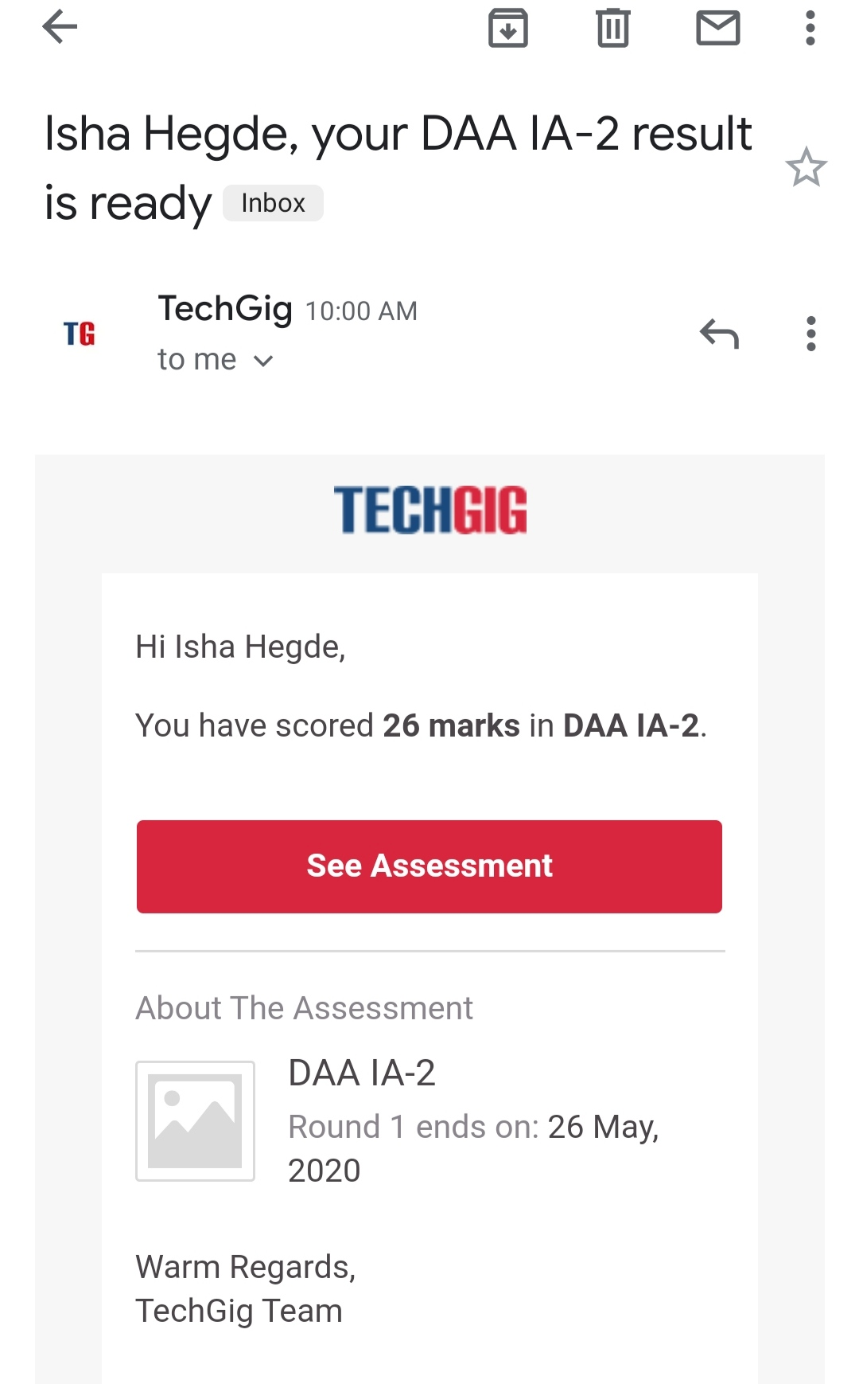

**Certification Course Summary:**

I continued with DIGITAL SECURITY AWARENESS, I completed module 9,10,11 and after each module I had to answer assessment and the criteria for qualification was above 80%.The module covers :

* module 9 will cover reading the end-user license agreement (EULA) to see what permissions are given for proper legal use of the software. By completing this module,we will know what piracy is and how to avoid it.
* This module 10 will cover security policies that are considered the basis for Standard Operation Procedures (SOP), including user account statements, internet access statements, email use statements, equipment acceptable use, and expectation of privacy.
* This course is an example of improving everyone's awareness of security. Hopefully, outlook on computer use has changed, but not in a negative way. By completing this module, we will have a better understanding of how to stay up-to-date in the world of digital security.

Final module is the course end assignment , I have completed the course and secured 92%.

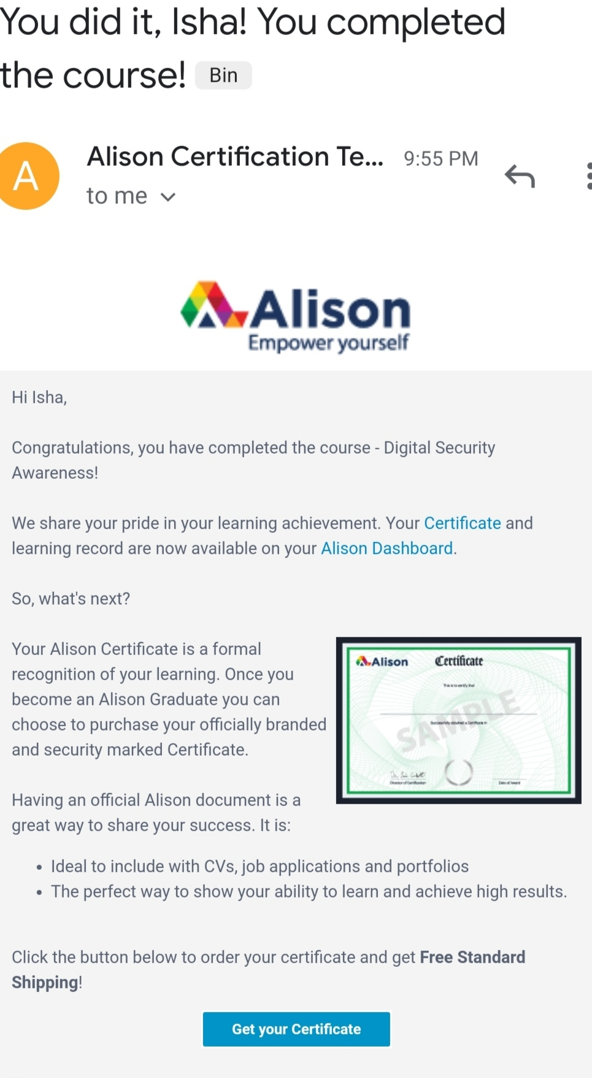

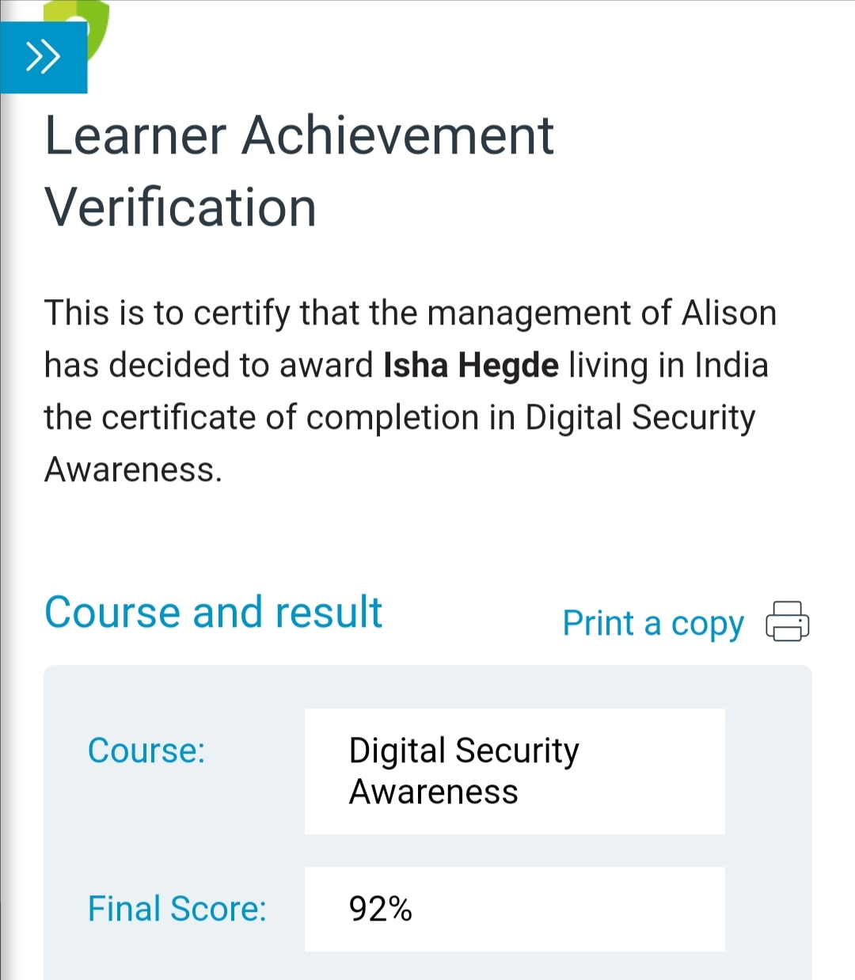

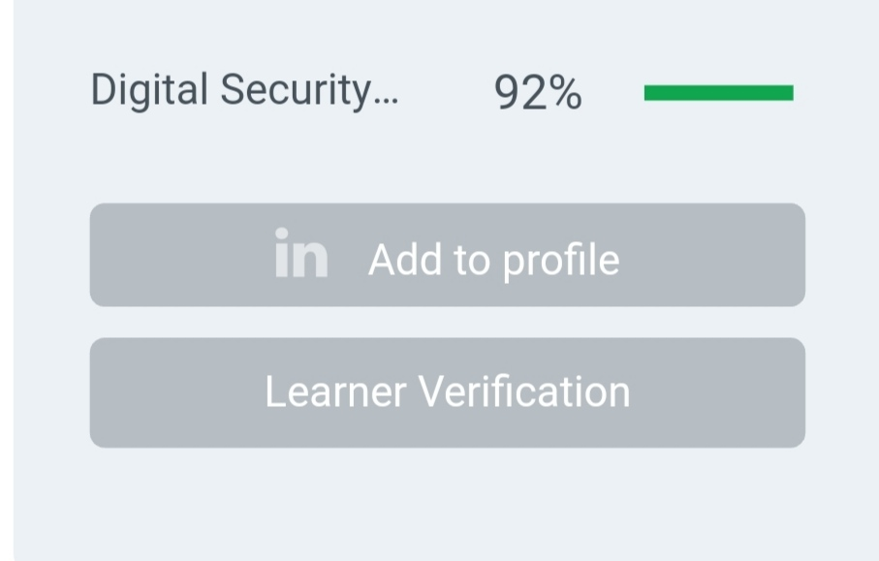

Modules covered are:

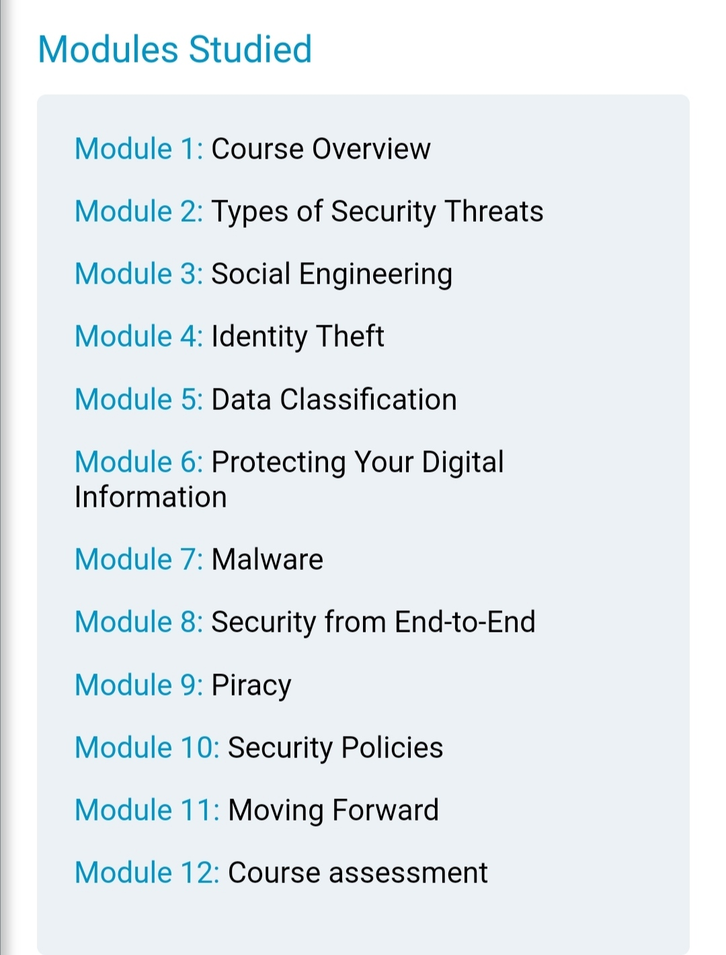

Online Coding summary:

**1.Write a program in c to print all permutations of a given string using array**

**2. Given an array A of size N where the array elements contain values from 1 to N with duplicates, the task is to find total number of subarrays which start and end with the same element.**

